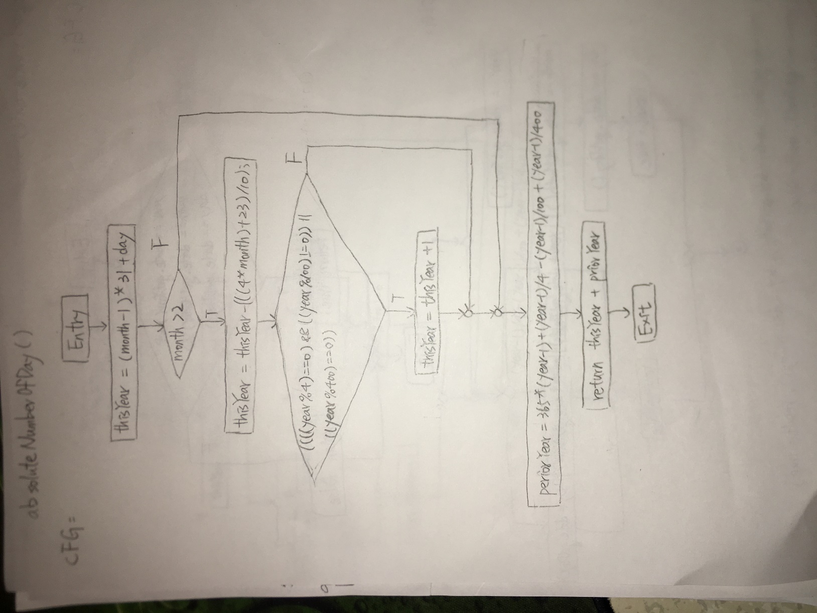

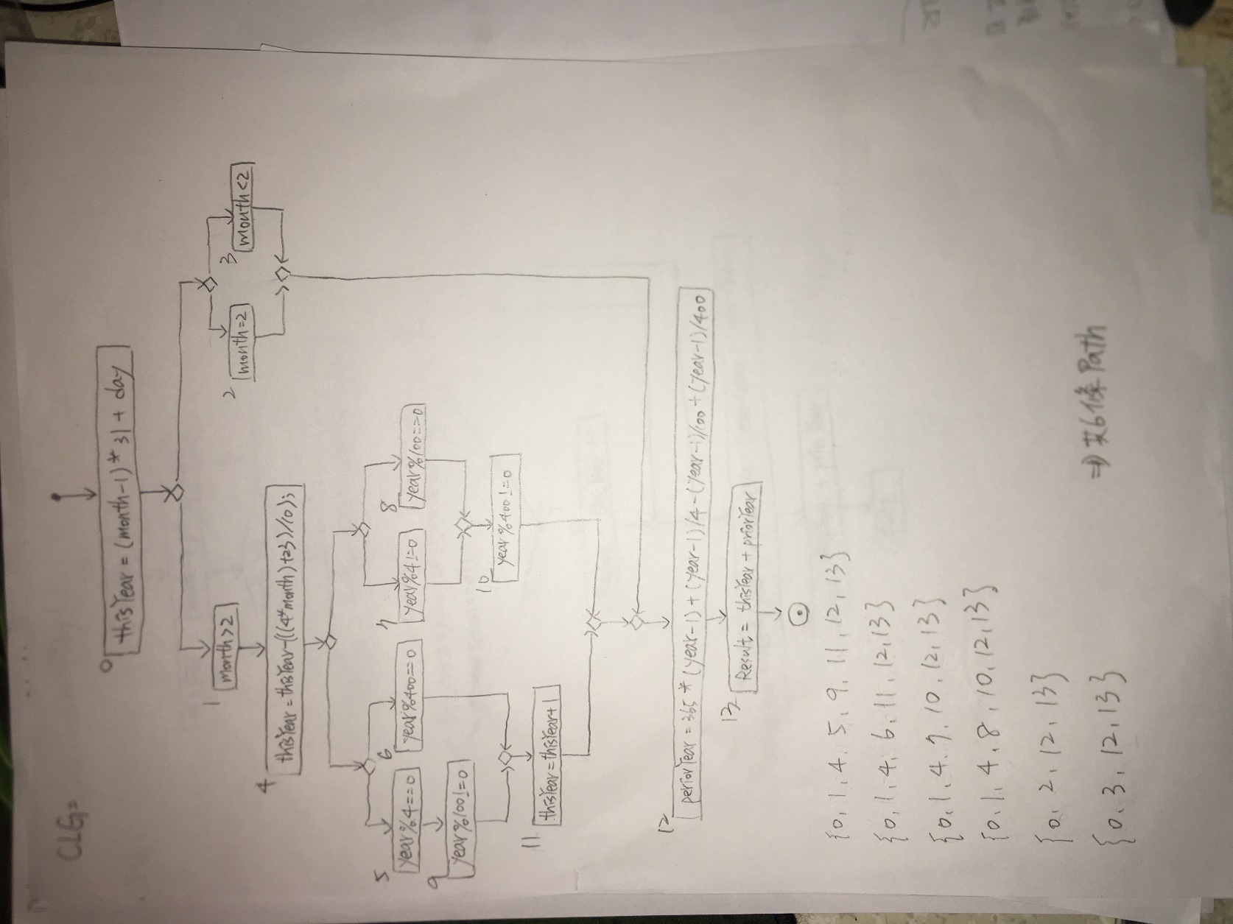

用CLP找Test input:

CLP:

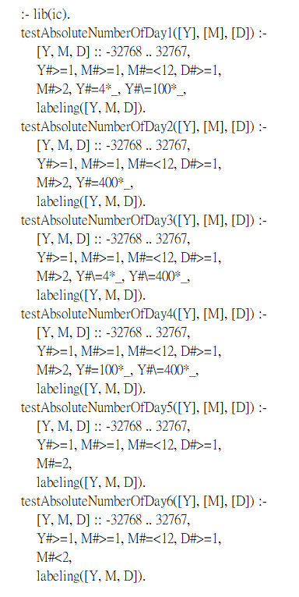

CLP solution: (Test input)

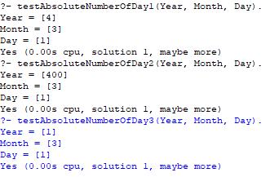

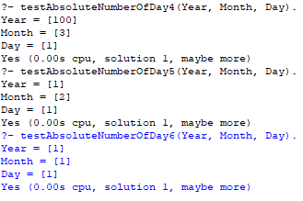

{Year=4, Month=3, Day=1}

{Year=400, Month=3, Day=1}

{Year=1, Month=3, Day=1}

{Year=100, Month=3, Day=1}

{Year=1, Month=2, Day=1}

{Year=1, Month=1, Day=1}

經模擬(OCL->CLP->solution(test output))得出test output:

{Year=4, Month=3, Day=1} => 1156

{Year=400, Month=3, Day=1} =>145792

{Year=1, Month=3, Day=1} => 60

{Year=100, Month=3, Day=1} => 36219

{Year=1, Month=2, Day=1} => 32

{Year=1, Month=1, Day=1} => 1